Screenshots or program listings must be copied into appropriate cells in the following table.
Save this evidence document as evidence_ followed by your centre number_ candidate number. For example: evidence_ zz999_9999 and insert your name, centre number and candidate number into the header above.
Examiners must be able to read the contents including any screenshots without the use of a magnifying glass. Answers that are not readable or missing will not be awarded any marks.
Save this evidence document at regular intervals, for example, every 10 minutes.
Question 1
Part 1(a)
ArrayNodes = [[0 for x in range(3)] for y in range(20)] # Declaration of ArrayNodes as a 2D array of 20 rows and 3 columns
RootPointer = -1 # Declaration of RootPointer as an integer
FreeNode = 0 # Declaration of FreeNode as an integer

Part 1(b)(i)
def AddNode(ArrayNodes, RootPointer, FreeNode):
NodeData = int(input("Enter the data: "))
if FreeNode <= 19:
ArrayNodes[FreeNode][0] = -1
ArrayNodes[FreeNode][1] = NodeData
ArrayNodes[FreeNode][2] = -1
if RootPointer == -1:
RootPointer = 0
else:
Placed = False
CurrentNode = RootPointer
while Placed is False:
if NodeData < ArrayNodes[CurrentNode][1]:
if ArrayNodes[CurrentNode][0] == -1:
ArrayNodes[CurrentNode][0] = FreeNode
Placed = True
else:
CurrentNode = ArrayNodes[CurrentNode][0]
else:
if ArrayNodes[CurrentNode][2] == -1:
ArrayNodes[CurrentNode][2] = FreeNode
Placed = True
else:
CurrentNode = ArrayNodes[CurrentNode][2]
FreeNode += 1
else:
print("Tree is full")
return ArrayNodes, RootPointer, FreeNode

Part 1(b)(ii)
def PrintAll(ArrayNodes):
# Print the header
print("LeftPointer \tData \tRightPointer")
for i in range(20):
print(ArrayNodes[i][0], '\t', ArrayNodes[i][1], '\t', ArrayNodes[i][2])

Part 1(c)
{Copy and paste the program code for question 1(c) here}

Part 1(d)(i)
for i in range(10):
ArrayNodes, RootPointer, FreeNode = AddNode(ArrayNodes, RootPointer, FreeNode)

PrintAll(ArrayNodes)

Part 1(d)(ii)
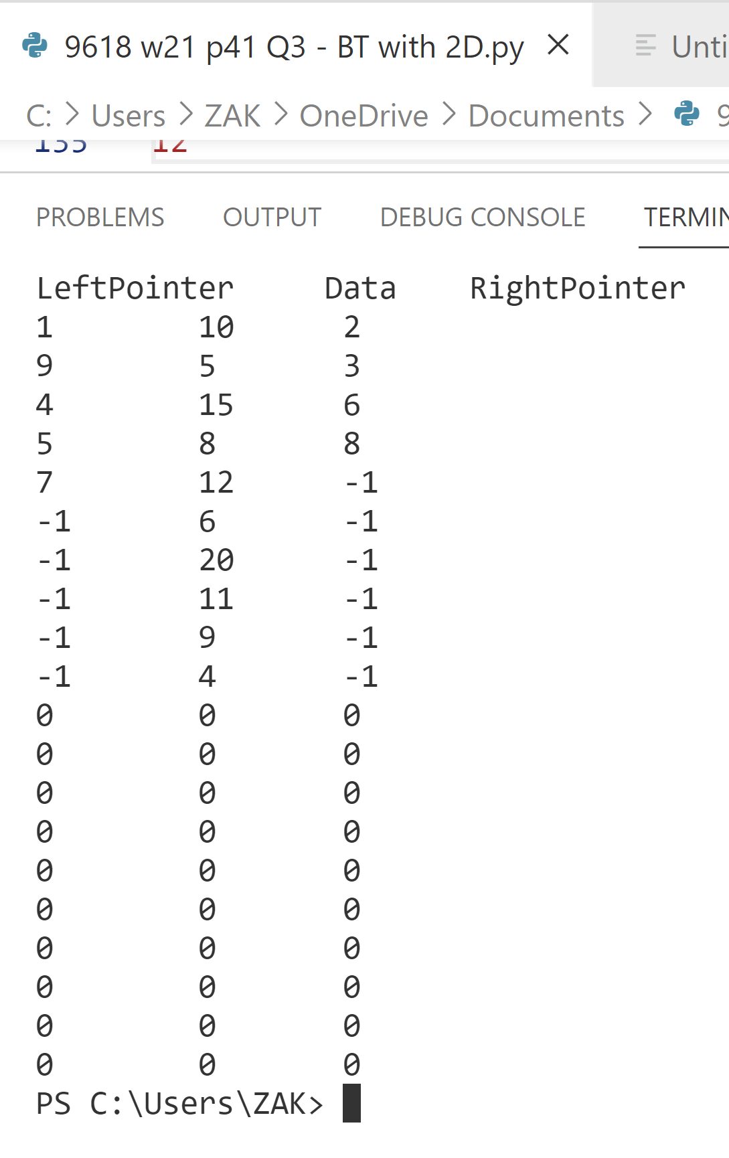

Question 2
Part 2(a)
{Copy and paste the program code for question 2(a) here}

Part 2(b)
{Copy and paste the program code for question 2(b) here}

Part 2(c)
{Copy and paste the program code for question 2(c) here}

Part 2(d)
{Copy and paste the program code for question 2(d) here}

Part 2(e)
{Copy and paste the program code for question 2(e) here}

Part 2(f)
{Copy and paste the program code for question 2(f) here}

Part 2(g)
{Copy and paste the program code for question 2(g) here}

Part 2(h)
{Copy and paste the screenshot(s) for question 2(h) here}

Question 3
Part 3(a)
{Copy and paste the program code for question 3(a) here}

Part 3(b)
{Copy and paste the program code for question 3(b) here}

Part 3(c)
{Copy and paste the program code for question 3(c) here}

Part 3(d)(i)
{Copy and paste the program code for question 3(d)(i) here}

Part 3(d)(ii)
{Copy and paste the screenshot for question 3(d)(ii) here}

Part 3(e)(i)
{Copy and paste the program code for question 3(e)(i) here}

Part 3(e)(ii)
{Copy and paste the screenshot for question 3(e)(ii) here}

